**Project Architecture**

**Basic Diagram :**

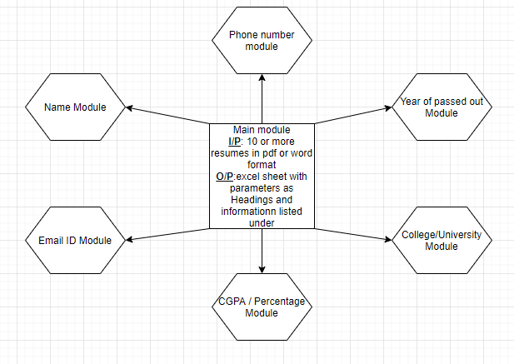

**Flowchart :**

